Non-Standard Terminology

📘 What is Non-Standard Terminology
# Source: AI Source: Provided by: [Data Path: Persons Table -> ID Column: 1, Name_En Column: Motasem Essam] -> From: [Chatgpt (GPT-4-turbo)] on [7/31/2025]
Non-standard terminology refers to terms that deviate from officially recognized, regulated, or widely accepted vocabulary within a particular field or language. These terms may arise from informal use, regional variations, slang, outdated usage, or miscommunication.

🧩 Key Characteristics:
# Source: AI Source: Provided by: [Data Path: Persons Table -> ID Column: 1, Name_En Column: Motasem Essam] -> From: [Chatgpt (GPT-4-turbo)] on [7/31/2025]
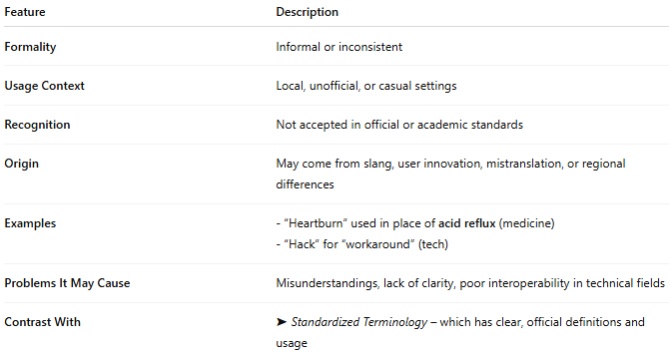
Feature | Description
Formality | Informal or inconsistent
Usage Context | Local, unofficial, or casual settings
Recognition | Not accepted in official or academic standards
Origin | May come from slang, user innovation, mistranslation, or regional differences
Examples | - “Heartburn” used in place of acid reflux (medicine) - “Hack” for “workaround” (tech)
Problems It May Cause | Misunderstandings, lack of clarity, poor interoperability in technical fields
Contrast With | ➤ Standardized Terminology – which has clear, official definitions and usage

🧠 Who Uses It?
# Source: AI Source: Provided by: [Data Path: Persons Table -> ID Column: 1, Name_En Column: Motasem Essam] -> From: [Chatgpt (GPT-4-turbo)] on [7/31/2025]
- General public
- Non-specialists
- Informal practitioners
- Students before being trained in standard terminology

🧪 In Practice:
# Source: AI Source: Provided by: [Data Path: Persons Table -> ID Column: 1, Name_En Column: Motasem Essam] -> From: [Chatgpt (GPT-4-turbo)] on [7/31/2025]
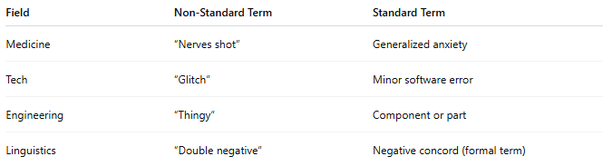
Field | Non-Standard Term | Standard Term
Medicine | “Nerves shot” | Generalized anxiety
Tech | “Glitch” | Minor software error
Engineering | “Thingy” | Component or part
Linguistics | “Double negative” | Negative concord (formal term)

